**Appendix**

**Instacart Customers Purchasing Behavior**

This analysis represents all four charts created in Power BI Dashboard

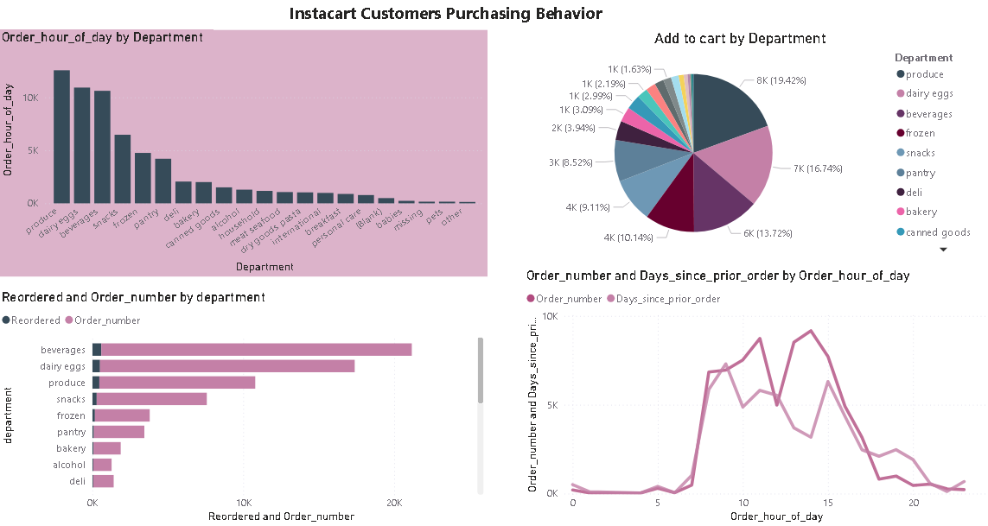

**Figure 1. Distribution of orders**

This Bar chart represents the distribution of orders from different departments based on the hour of the day they were placed. This displays which departments have the highest order at different times of the day. The Produce department shows the most essential items purchased reaching nearly fifteen (15) thousand units. 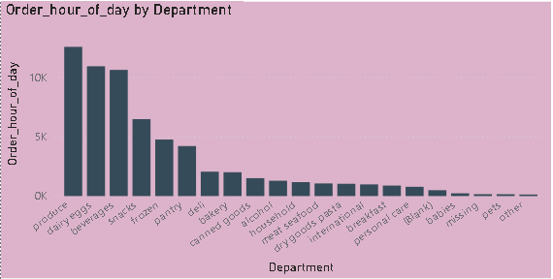

**Figure 2. Items added to cart by Department**

This Pie chart shows a breakdown of the total items added to the cart by various departments. Each department represents a section of the pie with the size corresponding to the portion of items added to the cart. The produce (19.42%) and dairy eggs (16.74%) indicate the two highest add to the cart followed by beverages (13.72%).

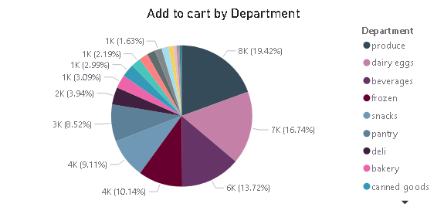

**Figure 3. Reorder items by department**

This Bar chart represents the frequency of reordered items as well as order numbers from various departments. It displays the trending product categories highlighting the three highest reordered items from the beverages, dairy eggs and produce department being the most popular.

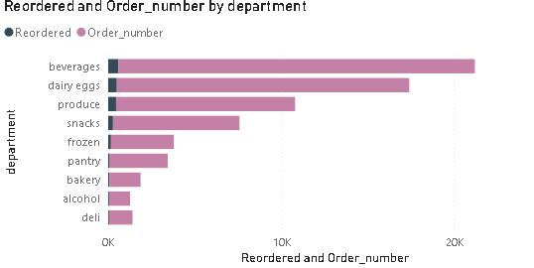

**Figure 4. Order number and Days since prior order by Order hour of day**

This Line graph plots the number of orders and the average days since the prior orders based on the order hour of the day. The trend reveals customers’ shopping behavior displaying when customers are most likely to reorder items. The order number volume appears to be highest between 9:00am and 4:00pm with a slight peak around 11:00am and 2:00pm. The days since prior orders demonstrate a similar pattern indicating customers tend to place orders at the same time consistently.

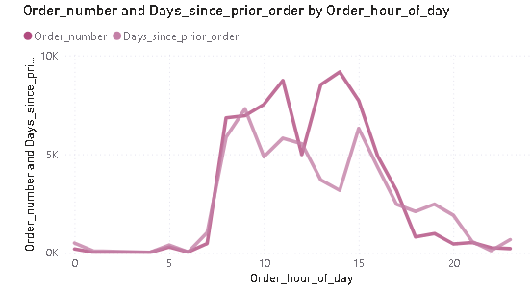

**Scenario Analysis**

**Figure 5: Scenario #1 - Items Reordered by Aisle**

This Bar chart plots the **Items Reordered by Aisle**, visualizes the quantity of reordered items across different product categories. The horizontal X-axis lists various aisles or product categories, such as yogurt, fresh fruits, and water seltzer, providing a granular view of product groupings. The vertical Y-axis, labeled "Items Reordered," represents the count or quantity of items reordered within each category. By comparing the length of the bars, we can quickly identify which aisles experience the highest reorder rates, with longer bars indicating greater reorder frequency.

**Figure 6: Scenario #2 - Average of reordered by department**

This bar chart plots the **Average of reordered by department**, provides a comparative overview of reorder rates across different departments. The vertical Y-axis lists broader departments or categories like beverages, alcohol, and dairy & eggs. The horizontal X-axis, labeled Average of reordered, displays the percentage of reordered items within each department relative to the overall total. The length of each bar corresponds to the percentage of reordered items for that department. This visualization allows for quick identification of departments with strong performance reorders, such as beverages, alcohol, and dairy eggs, which exhibit the highest percentages in this example.

**Figure 7: Scenario #3 - Sum of days_since_prior_order**

This Bar chart plots the **Sum of days_since_prior_order** provides an insight into the overall order frequency. The vertical Y-axis, labeled Sum of days_since_prior_order, represents the total number of days accumulated since the previous orders and an overall summary of an aggregated data point for the entire dataset. The length of the single bar corresponds to the total sum of days since prior orders. This visualization offers a concise view of the overall time elapsed from previous orders, giving a general sense of customer ordering habits.

